Irregular-Piece Dissection

Definition
# Source: AI Source: Provided by: [Data Path: Persons Table -> ID Column: 1, Name_En Column: Motasem Essam] -> From: [ChatGPT] on [7/25/2026]
Irregular-Piece Dissection is a geometric dissection method in which a figure is divided into two or more pieces, with at least some pieces having irregular shapes rather than standard shapes such as squares, rectangles, or regular polygons.
The pieces may have unequal areas, unequal side lengths, curved boundaries, or combinations of these features. They can be studied individually, measured, or rearranged to form another figure.
Simple definition: Irregular-piece dissection is dividing a geometric figure into pieces that include irregularly shaped regions.
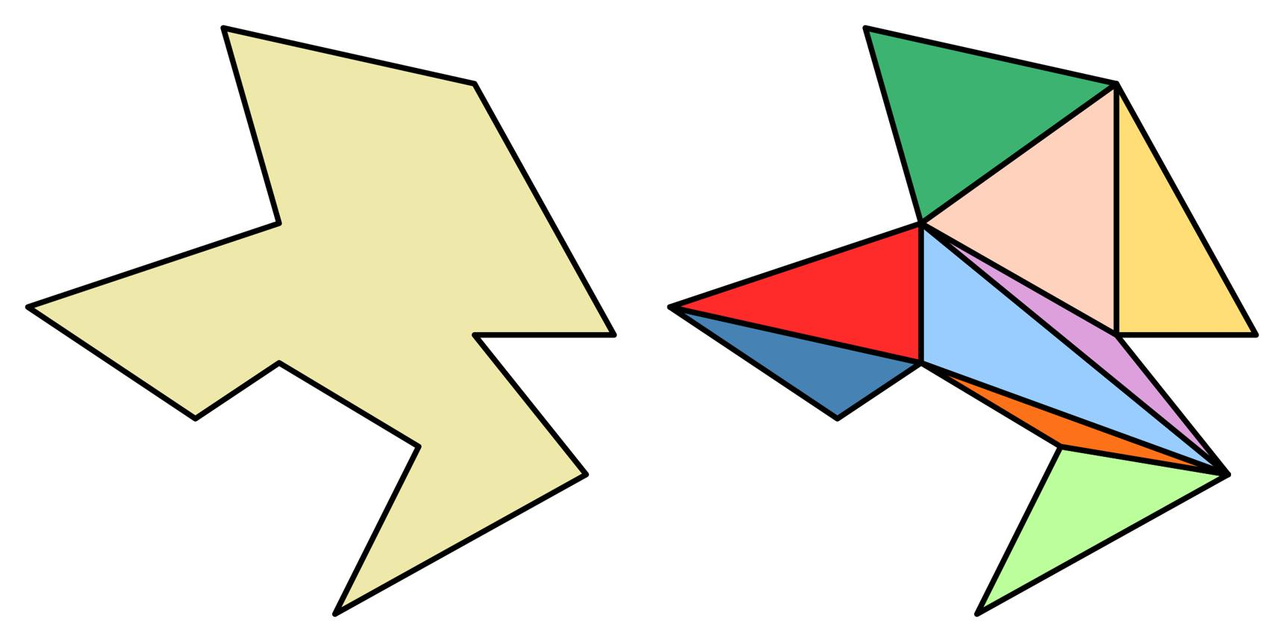
Important distinction: “Irregular-piece dissection” is a descriptive classification, not a universally standardized mathematical category. A piece may be irregular because its sides, angles, or boundary are not arranged in a regular pattern. The pieces do not all need to be irregular; some may be regular while others are irregular.

Main Classification
# Source: AI Source: Provided by: [Data Path: Persons Table -> ID Column: 1, Name_En Column: Motasem Essam] -> From: [ChatGPT] on [7/25/2026]
The following is a practical classification. Some types overlap because they describe different aspects of the same dissection.

1. Irregular-Polygon Piece Dissection
# Source: AI Source: Provided by: [Data Path: Persons Table -> ID Column: 1, Name_En Column: Motasem Essam] -> From: [ChatGPT] on [7/25/2026]
A polygon is divided into pieces that include irregular polygons with unequal sides or angles.
Example: Dividing an irregular hexagon into three smaller irregular polygons.
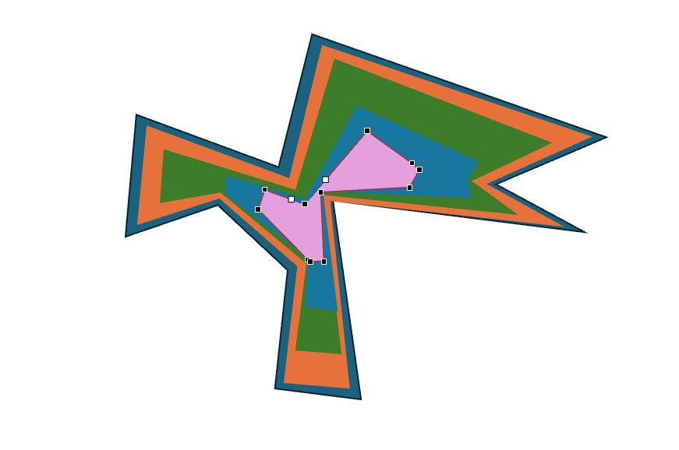
Detailed Mathematical Examples
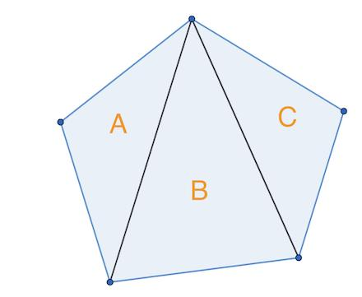
Consider an irregular polygon divided into three non-overlapping polygonal pieces.
Suppose the areas of the pieces are $7$, $11$, and $14$ square units.
The total area is
$$A=7+11+14=32$$
Therefore, the original polygon has an area of $32$ square units.

2. Concave-Figure Irregular-Piece Dissection
# Source: AI Source: Provided by: [Data Path: Persons Table -> ID Column: 1, Name_En Column: Motasem Essam] -> From: [ChatGPT] on [7/25/2026]
A concave figure, which has at least one inward indentation, is divided into pieces that may also be irregular.
Example: Splitting an L-shaped polygon using diagonal and horizontal segments.
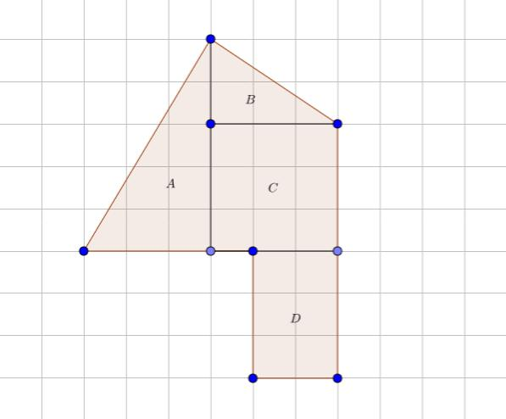
Detailed Mathematical Examples
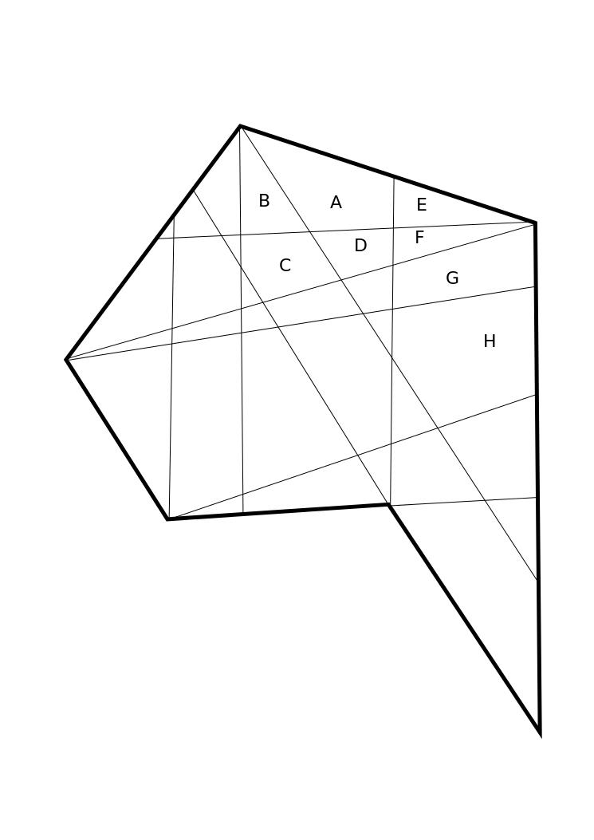
Consider an L-shaped figure formed by removing a $3×2$ rectangle from a $7×5$ rectangle.
The area of the original L-shaped figure is
$$A=\left(7×5\right)-\left(3×2\right)=29$$
If internal cuts divide it into three pieces with areas $9$, $8$, and $12$, then
$$9+8+12=29$$
The sum confirms that the pieces account for the original area, provided the cuts form a valid partition.

3. Oblique-Cut Irregular-Piece Dissection
# Source: AI Source: Provided by: [Data Path: Persons Table -> ID Column: 1, Name_En Column: Motasem Essam] -> From: [ChatGPT] on [7/25/2026]
Pieces are created using slanted cuts rather than only horizontal or vertical segments.
Example: Cutting a five-sided irregular polygon with two diagonal segments.
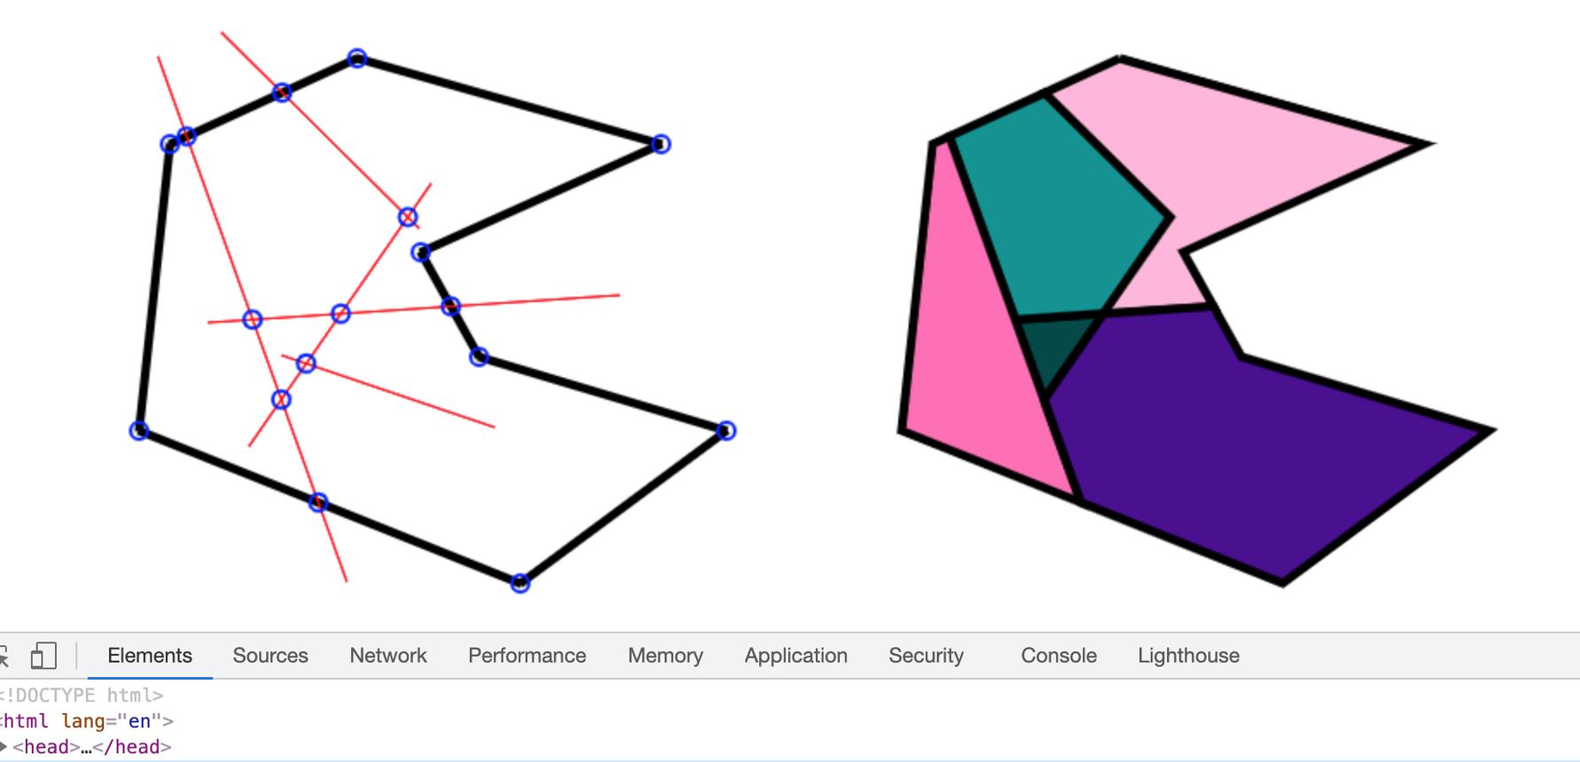
Detailed Mathematical Examples
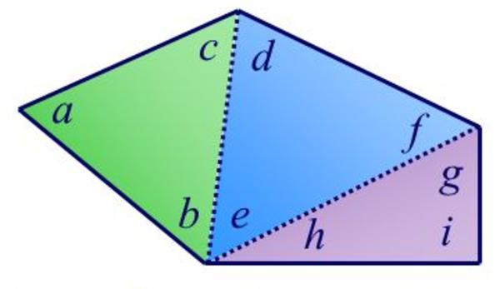
Slanted cuts can create pieces with unequal angles and side lengths.
For example, an irregular polygon might be divided into pieces with areas
$$A_{1}=6, A_{2}=10, A_{3}=15$$
Thus,
$$A_{\text{total}}=6+10+15=31$$
The pieces need not be congruent or similar.

4. Curved-Boundary Irregular-Piece Dissection
# Source: AI Source: Provided by: [Data Path: Persons Table -> ID Column: 1, Name_En Column: Motasem Essam] -> From: [ChatGPT] on [7/25/2026]
At least one piece has a curved boundary, so the pieces are not all ordinary polygons.
Example: Dividing a shape with a wavy edge into regions using straight and curved cuts.
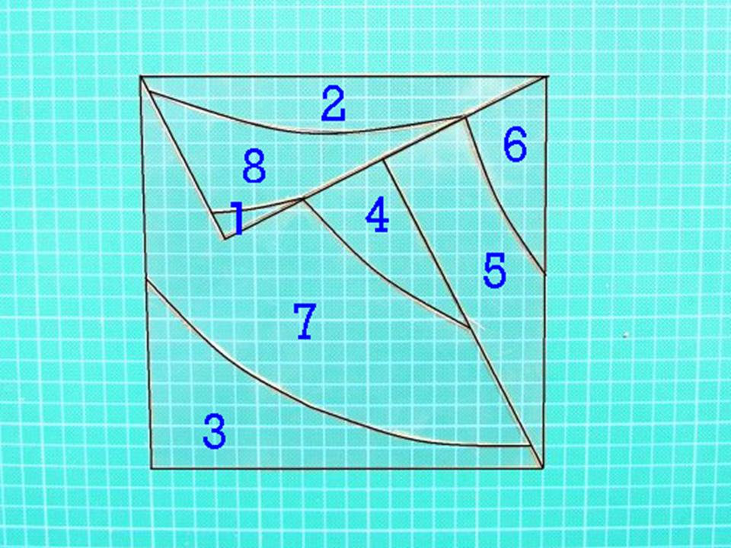
Detailed Mathematical Examples
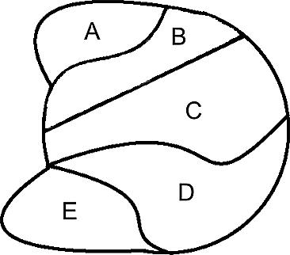
Suppose a region contains both straight and curved boundaries. Its pieces may include irregular polygonal regions and curved regions.
If a piece consists of a rectangle and a semicircle attached without overlap, its area can be calculated as
$$A=lw+\frac{1}{2}πr^{2}$$
For $l=6$, $w=4$, and $r=2$,
$$A=24+2π≈30.28$$
This formula applies when the two component regions meet without overlapping.

5. Unequal-Area Irregular-Piece Dissection
# Source: AI Source: Provided by: [Data Path: Persons Table -> ID Column: 1, Name_En Column: Motasem Essam] -> From: [ChatGPT] on [7/25/2026]
The pieces have different areas and may also have different shapes.
Example: Dividing a region of area $50$ square units into pieces with areas $8$, $12$, and $30$ square units.
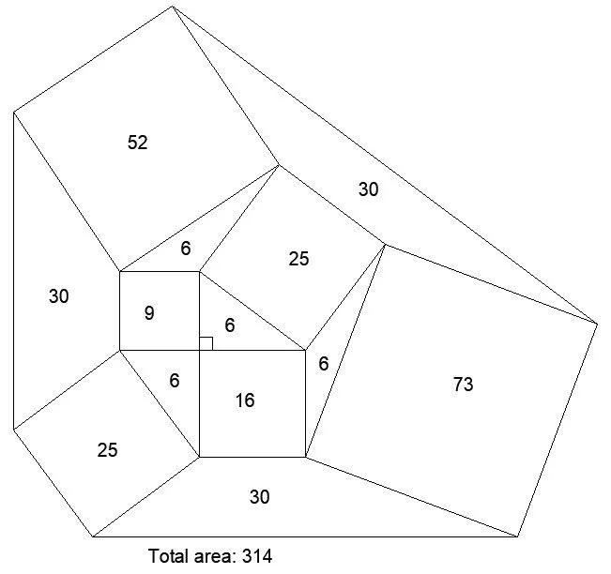
Detailed Mathematical Examples
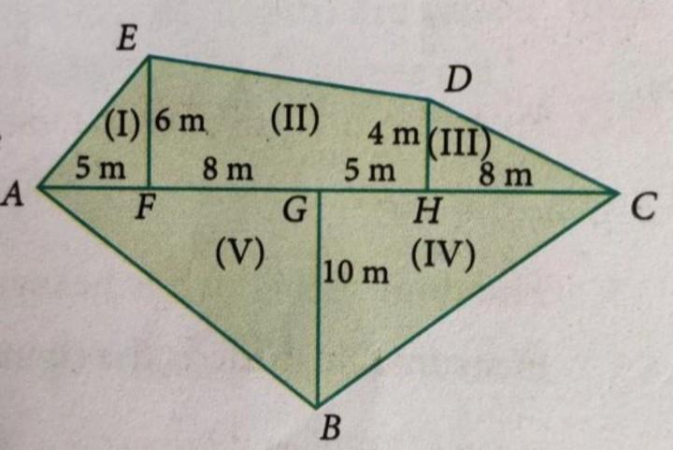
Suppose a figure is partitioned into three irregular pieces with areas $8$, $12$, and $30$ square units.
$$A_{\text{total}}=8+12+30=50$$
The pieces have unequal areas because
$$8≠12≠30$$
Unequal area does not necessarily mean unequal shape, and equal shape does not necessarily mean equal placement.

6. Equal-Area Irregular-Piece Dissection
# Source: AI Source: Provided by: [Data Path: Persons Table -> ID Column: 1, Name_En Column: Motasem Essam] -> From: [ChatGPT] on [7/25/2026]
The pieces have equal areas, even though their shapes may be different and irregular.
Example: Dividing a $36$-square-unit region into three pieces of area $12$ square units each.
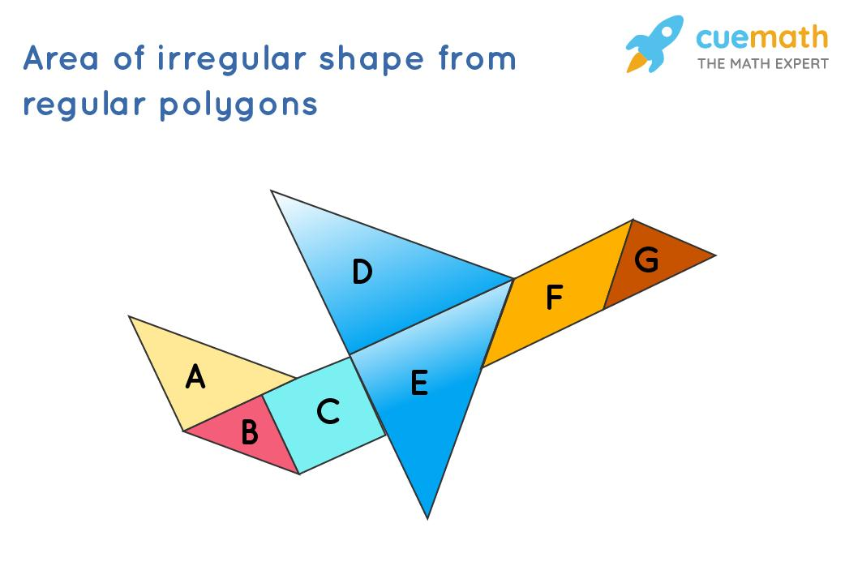
Detailed Mathematical Examples
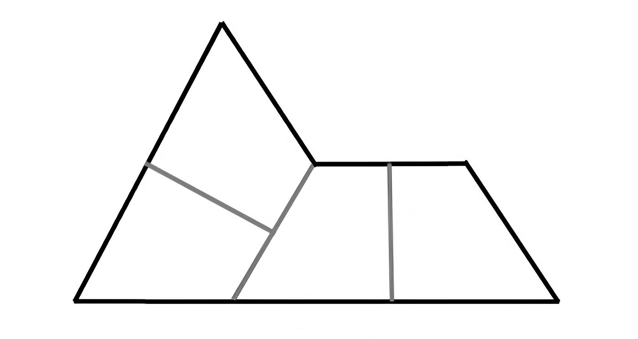
Suppose an irregular figure has a total area of $36$ square units and is divided into three pieces of equal area.
$$A_{\text{each}}=\frac{36}{3}=12$$
Each piece must have area $12$ square units, but the pieces may have different shapes and perimeters.
Important: Equal area alone does not guarantee that pieces can be rearranged into one another without further cutting.

7. Mixed Regular-and-Irregular Piece Dissection
# Source: AI Source: Provided by: [Data Path: Persons Table -> ID Column: 1, Name_En Column: Motasem Essam] -> From: [ChatGPT] on [7/25/2026]
The original figure is divided into a combination of standard pieces and irregular pieces.
Example: A dissection containing a triangle, a rectangle, and an irregular pentagon.
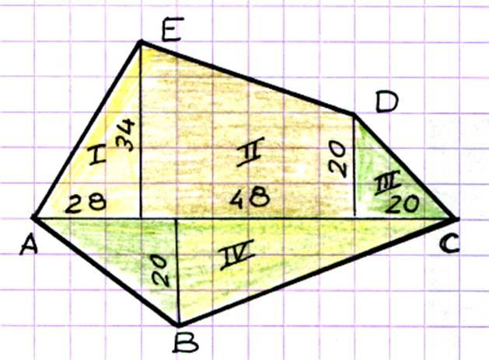
Detailed Mathematical Examples
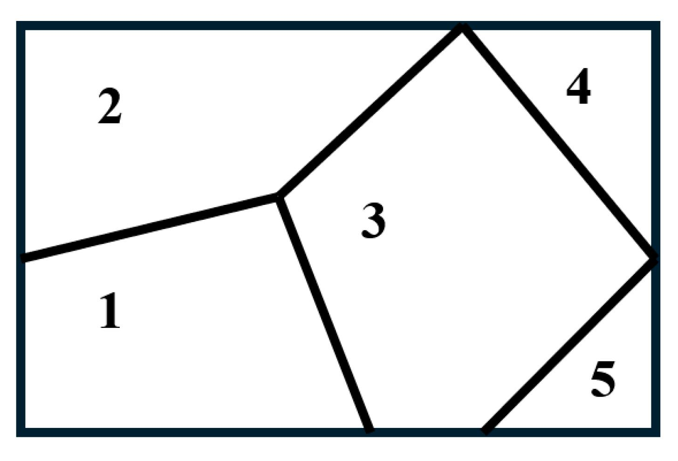
Suppose a figure consists of three non-overlapping pieces:
- Triangle: $A_{1}=\frac{1}{2}\left(4\right)\left(3\right)=6$
- Rectangle: $A_{2}=5×3=15$
- Irregular polygon: $A_{3}=13$
The total area is
$$A_{\text{total}}=6+15+13=34$$
Standard area formulas can be used for the regular pieces, while the irregular piece may require further subdivision, coordinates, or another area method.

8. Multiple-Cut Irregular-Piece Dissection
# Source: AI Source: Provided by: [Data Path: Persons Table -> ID Column: 1, Name_En Column: Motasem Essam] -> From: [ChatGPT] on [7/25/2026]
Several intersecting or non-intersecting cuts create many irregular regions.
Example: Dividing an irregular polygon with four internal segments to produce multiple pieces.
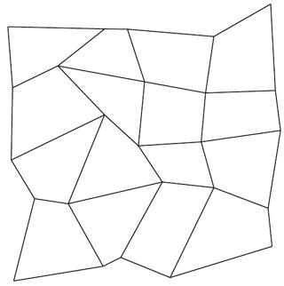
Detailed Mathematical Examples
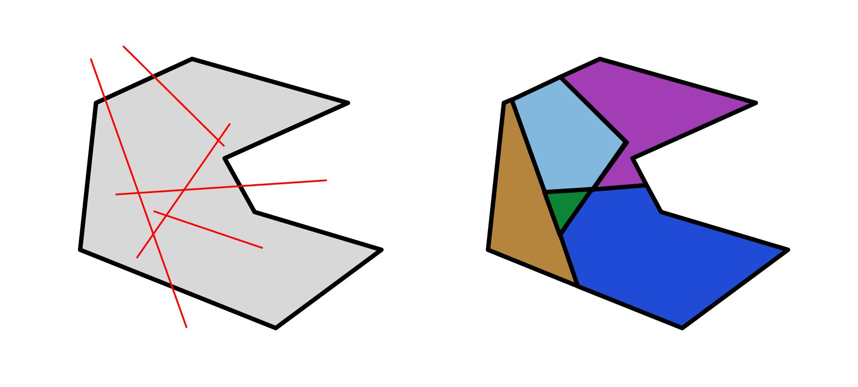
Several cuts can produce a larger number of pieces. If the resulting pieces have areas $A_{1},A_{2},…,A_{n}$, then
$$A_{\text{total}}=\sum_{i=1}^{n}{A_{i}}$$
This assumes the pieces cover the original figure completely, with no gaps or overlapping interiors.

9. Rearrangement-Based Irregular-Piece Dissection
# Source: AI Source: Provided by: [Data Path: Persons Table -> ID Column: 1, Name_En Column: Motasem Essam] -> From: [ChatGPT] on [7/25/2026]
Irregular pieces are separated and rearranged to form a different figure, generally without changing their individual shapes or areas.
Example: Rearranging several irregular pieces from one polygon to form a different polygon.
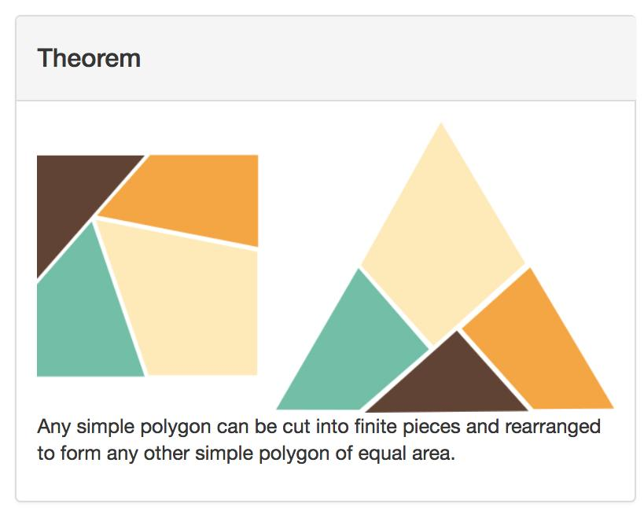
Detailed Mathematical Examples
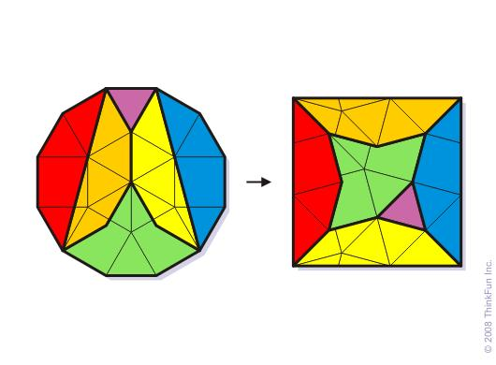
In rearrangement-based dissection, the pieces are moved and reassembled without changing their shapes.
If the original figure has area $A$, then the rearranged figure also has area $A$, assuming every piece is preserved and used exactly once.
$$A_{\text{original}}=A_{\text{rearranged}}$$
The perimeter, however, may change because the arrangement of the outer boundaries can change.

10. Multi-Stage Irregular-Piece Dissection
# Source: AI Source: Provided by: [Data Path: Persons Table -> ID Column: 1, Name_En Column: Motasem Essam] -> From: [ChatGPT] on [7/25/2026]
A figure is divided in stages: an initial division is followed by further cuts that create smaller irregular pieces.
Example: Dividing an irregular polygon into three regions and then subdividing one region into four smaller pieces.
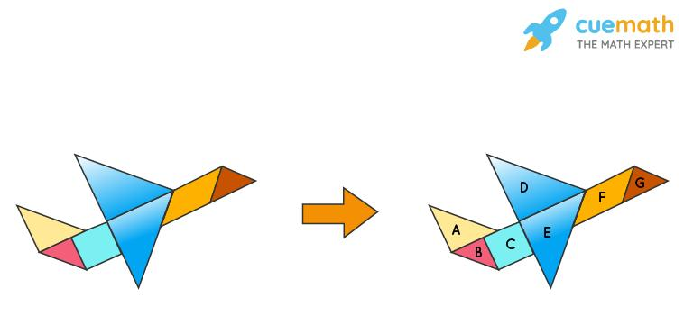
Detailed Mathematical Examples
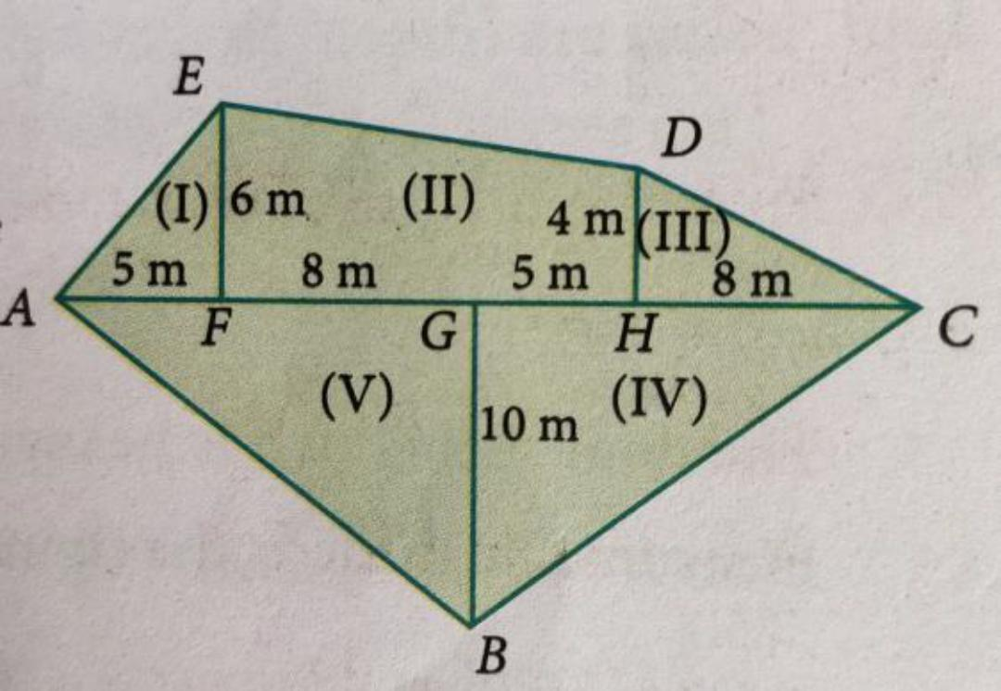
A multi-stage dissection uses successive subdivisions.
For example:
- Divide a figure of area $48$ into three regions with areas $15$, $18$, and $15$.
- Subdivide the region of area $18$ into three pieces, each of area $6$.
The final collection has five pieces, and its total area remains
$$15+15+6+6+6=48$$

Key Formulas
# Source: AI Source: Provided by: [Data Path: Persons Table -> ID Column: 1, Name_En Column: Motasem Essam] -> From: [ChatGPT] on [7/25/2026]
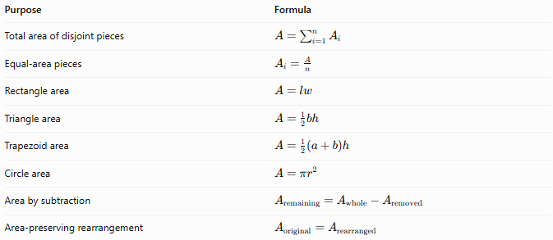
Purpose | Formula
Total area of disjoint pieces | $$A=\sum_{i=1}^{n}{A_{i}}$$
Equal-area pieces | $$A_{i}=\frac{A}{n}$$
Rectangle area | $$A=lw$$
Triangle area | $$A=\frac{1}{2}bh$$
Trapezoid area | $$A=\frac{1}{2}\left(a+b\right)h$$
Circle area | $$A=πr^{2}$$
Area by subtraction | $$A_{\text{remaining}}=A_{\text{whole}}-A_{\text{removed}}$$
Area-preserving rearrangement | $$A_{\text{original}}=A_{\text{rearranged}}$$
For a polygon with vertices $\left(x_{1},y_{1}\right),…,\left(x_{n},y_{n}\right)$, its area can also be found using the shoelace formula:
$$A=\frac{1}{2}\left|\sum_{i=1}^{n}{\left(x_{i}y_{i+1}-y_{i}x_{i+1}\right)}\right|$$
where the final vertex is followed by the first vertex.

Comparison with Other Dissection Types
# Source: AI Source: Provided by: [Data Path: Persons Table -> ID Column: 1, Name_En Column: Motasem Essam] -> From: [ChatGPT] on [7/25/2026]
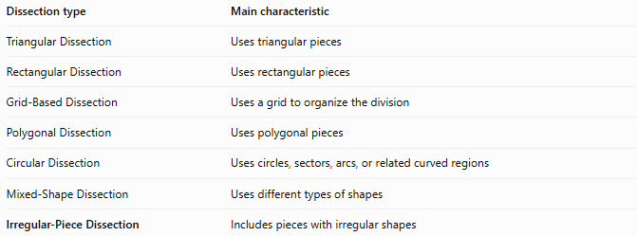
Dissection type | Main characteristic
Triangular Dissection | Uses triangular pieces
Rectangular Dissection | Uses rectangular pieces
Grid-Based Dissection | Uses a grid to organize the division
Polygonal Dissection | Uses polygonal pieces
Circular Dissection | Uses circles, sectors, arcs, or related curved regions
Mixed-Shape Dissection | Uses different types of shapes
Irregular-Piece Dissection | Includes pieces with irregular shapes
These categories can overlap. For example, an irregular-piece dissection can also be polygonal, grid-assisted, mixed-shape, or rearrangement-based.

Classification Summary
# Source: AI Source: Provided by: [Data Path: Persons Table -> ID Column: 1, Name_En Column: Motasem Essam] -> From: [ChatGPT] on [7/25/2026]
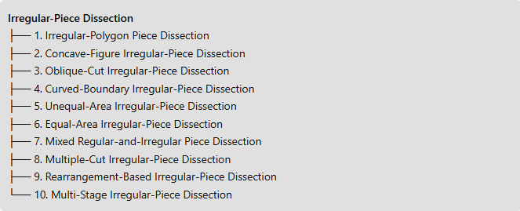
Irregular-Piece Dissection
├── 1. Irregular-Polygon Piece Dissection
├── 2. Concave-Figure Irregular-Piece Dissection
├── 3. Oblique-Cut Irregular-Piece Dissection
├── 4. Curved-Boundary Irregular-Piece Dissection
├── 5. Unequal-Area Irregular-Piece Dissection
├── 6. Equal-Area Irregular-Piece Dissection
├── 7. Mixed Regular-and-Irregular Piece Dissection
├── 8. Multiple-Cut Irregular-Piece Dissection
├── 9. Rearrangement-Based Irregular-Piece Dissection
└── 10. Multi-Stage Irregular-Piece Dissection

Key Points
# Source: AI Source: Provided by: [Data Path: Persons Table -> ID Column: 1, Name_En Column: Motasem Essam] -> From: [ChatGPT] on [7/25/2026]
- Irregular-piece dissection includes at least one irregularly shaped piece.
- Pieces may have equal or unequal areas.
- A piece may have straight boundaries, curved boundaries, or both.
- Irregular pieces can be further subdivided into triangles or other standard shapes to calculate their areas.
- A valid dissection must cover the original figure without gaps or overlapping interiors.
- Rearranging pieces preserves total area when all pieces are retained without distortion.

Conclusion
# Source: AI Source: Provided by: [Data Path: Persons Table -> ID Column: 1, Name_En Column: Motasem Essam] -> From: [ChatGPT] on [7/25/2026]
Irregular-Piece Dissection is a flexible way to divide complex geometric figures into regions that do not necessarily follow standard shapes. It is useful for area calculations, geometric puzzles, figure rearrangement, and the study of complex polygons and curved regions. Its subtypes describe different features of the dissection, so they should be treated as overlapping descriptive categories rather than mutually exclusive mathematical classes.

